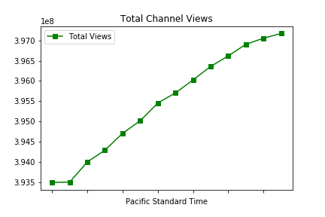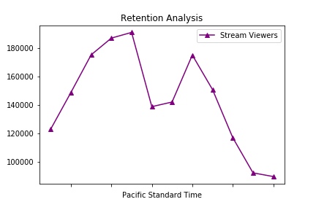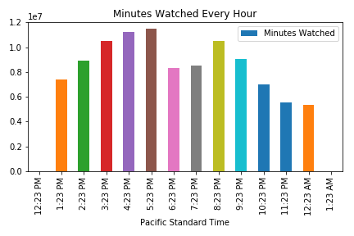

**Summary Metrics**

**Follower Growth**

**Total Channel Views**

**Stream Viewers**

**Minutes Watched**

**Twitch Content Report**